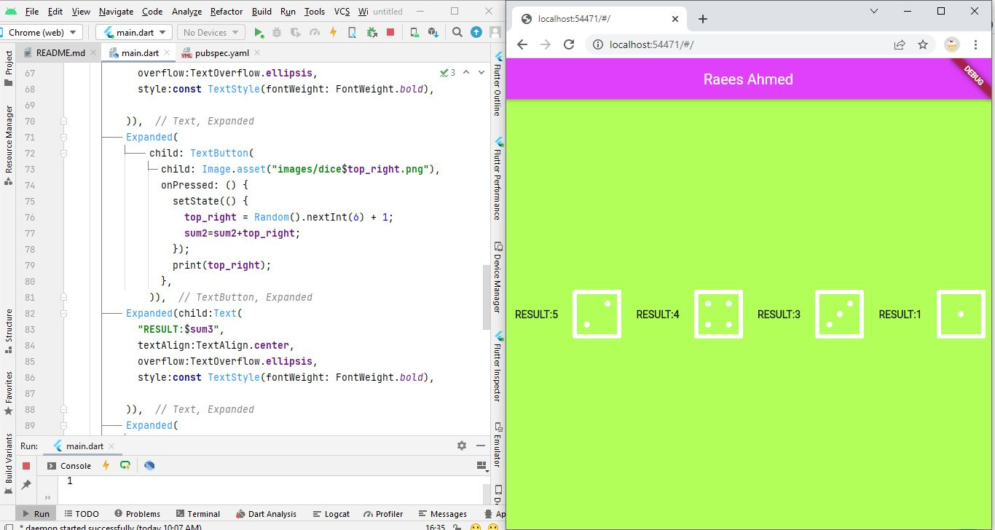

**Muhammad Raees**

**FA19-BCS-114**

**--------------------------------------------------------**

**import 'package:flutter/material.dart'**;  
**import 'dart:math'**;  
  
**void** main() {  
 runApp(MyDiceApp());  
}  
  
**class** MyDiceApp **extends** StatelessWidget {  
 @override  
 Widget build(BuildContext context) {  
 **return** MaterialApp(  
 home: Scaffold(  
 backgroundColor: Colors.*lightGreenAccent*,  
 appBar: AppBar(  
 centerTitle: **true**,  
 title: Text(**"Raees Ahmed"** ),  
 backgroundColor: Colors.*purpleAccent*,  
 ),  
 body: ClickAblbeDiceApp(),  
 ),  
 );  
 }  
}  
  
**class** ClickAblbeDiceApp **extends** StatefulWidget {  
 @override  
 _ClickAblbeDiceAppState createState() => _ClickAblbeDiceAppState();  
}  
  
**class** _ClickAblbeDiceAppState **extends** State<ClickAblbeDiceApp> {  
 int **top_left** = 5;  
 int **top_right** = 6;  
 int **bottom_left** = 6;  
 int **bottom_right** = 1;  
 int **sum1**=0;  
 int **sum2**=0;  
 int **sum3**=0;  
 int **sum4**=0;  
 @override  
 Widget build(BuildContext context) {  
 **return** Center(  
 child: Row(  
 children: [  
 Expanded(child:Text(  
 **"RESULT:**$**sum1"**,  
 textAlign:TextAlign.**center**,  
 overflow:TextOverflow.**ellipsis**,  
 style:**const** TextStyle(fontWeight: FontWeight.*bold*),  
  
 )),  
 Expanded(  
 child: TextButton(  
 child: Image.asset(**"images/dice**$**top_left.png"**),  
 onPressed: () {  
 setState(() {  
 **top_left** = Random().nextInt(6) + 1;  
 **sum1**=**sum1**+**top_left**;  
  
 });  
 print(**top_left**);  
 },  
 )),  
 Expanded(child:Text(  
 **"RESULT:**$**sum2"**,  
 textAlign:TextAlign.**center**,  
 overflow:TextOverflow.**ellipsis**,  
 style:**const** TextStyle(fontWeight: FontWeight.*bold*),  
  
 )),  
 Expanded(  
 child: TextButton(  
 child: Image.asset(**"images/dice**$**top_right.png"**),  
 onPressed: () {  
 setState(() {  
 **top_right** = Random().nextInt(6) + 1;  
 **sum2**=**sum2**+**top_right**;  
 });  
 print(**top_right**);  
 },  
 )),  
 Expanded(child:Text(  
 **"RESULT:**$**sum3"**,  
 textAlign:TextAlign.**center**,  
 overflow:TextOverflow.**ellipsis**,  
 style:**const** TextStyle(fontWeight: FontWeight.*bold*),  
  
 )),  
 Expanded(  
 child: TextButton(  
 child: Image.asset(**"images/dice**$**bottom_left.png"**),  
 onPressed: () {  
 setState(() {  
 **bottom_left** = Random().nextInt(6) + 1;  
 **sum3**=**sum3**+**bottom_left**;  
 });  
 print(**bottom_left**);  
 },  
 )),  
 Expanded(child:Text(  
 **"RESULT:**$**sum4"**,  
 textAlign:TextAlign.**center**,  
 overflow:TextOverflow.**ellipsis**,  
 style:**const** TextStyle(fontWeight: FontWeight.*bold*),  
  
 )),  
 Expanded(  
 child: TextButton(  
 child: Image.asset(**"images/dice**$**bottom_right.png"**),  
 onPressed: () {  
 setState(() {  
 **bottom_right** = Random().nextInt(6) + 1;  
 **sum4**=**sum4**+**bottom_right**;  
 });  
 print(**bottom_right**);  
 },  
 )),  
 ],  
 ),  
 );  
 }  
}